BIG BANG PHYSICS
YEAR 10 TERM PLANNER 2018

PERIOD 1 | PERIOD 2 | PERIOD 3 | PERIOD 4 | WK
The Universe  Explain the composition of the universe | How big is the Universe? | The Expansion model of the Universe | Discuss the significance of Hubble’s Law.  V = H_{o}D  Measuring Red shift | wk  1
The Big Bang  How did the Universe begin? | What is the evidence for the Big Bang Theory. | The “Milky Way” and other galaxies  Where do we fit into the space? | What are galaxies?  How do galaxies vary? | Wk  2
Light Speed  What is the speed of light? | How is the concept of light years related to space distance? | How do we look back in time?  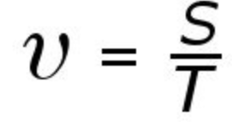 | Special Relativity and other things. | Wk  3
What happens to time when you travel close to speed of light?  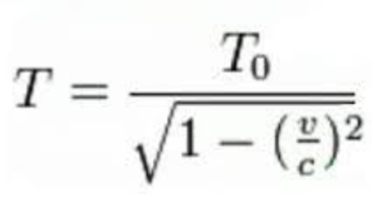 | What happens to time when you travel close to speed of light?   | What happens to time when you travel close to speed of light?   | What else happens at light speed? | WK  4
Gravitation theory  What is gravity?  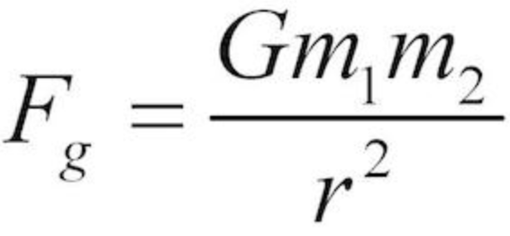 | What is Gravity’s fundamental role in the universe? | Calculating the speed of falling objects | How does gravity effect the energy of an object?  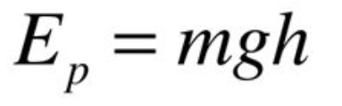 | WK  5
Black Holes  What are black holes? | Black hole activity | Response Task  The Universe | Circular Motion  How fast to objects go moving in circles?  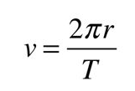 | Wk  6
 | What forces are needed to turn in circles?  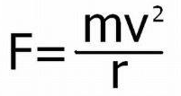 | What forces are needed to turn in circles?   | MID-TERM BREAK | WK  7
MID-TERM BREAK | Investigation Task  Centripetal forces | Investigation Task  Centripetal forces | Investigation Task  Centripetal forces  Validation Test | WK  8
Satellite Motion  What are satellites?  Why do satellites stay up in space? | How fast do satellites move?   | How do satellites accelerate?  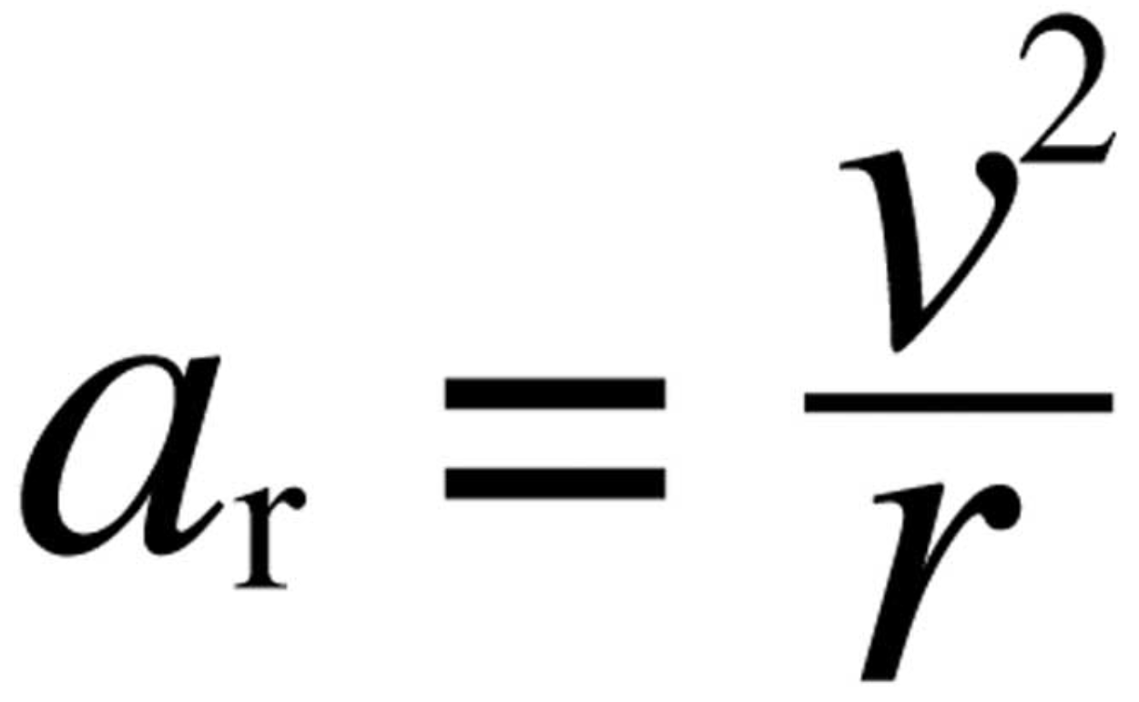 | Natural and man-made satellites | WK  9
Energy  What does work have to do with potential energy?   | What does work have to do with potential energy?   | What does work have to do with Kinetic energy?  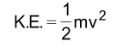 | What does work have to do with Kinetic energy?   | WK  10
Conservation of energy calculations | Conservation of energy calculations  Revision | Topic Test | Activity | WK  11

